# 

# Task 5 – Credit Submission

Student Number: 103181157  
Student Name: Nguyen Nam Tung

### Credit 5a

Paste your screen capture(s) for this task here.

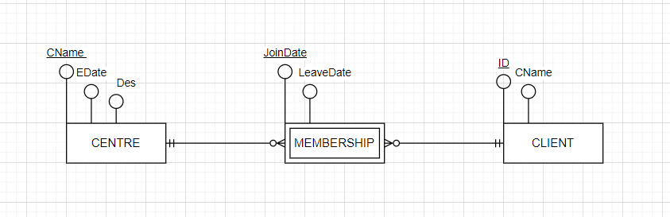

|  |  |  |
| --- | --- | --- |
| CName | EDate | Des |
| Hawthorne | 2003 | Has discount in March |
| Glen Iris | 2002 | Holiday surcharge |
| Box Hill | 2009 | Monthly Payment |

|  |  |
| --- | --- |
| ID | CName |
| 1 | Nguyen Nam Tung |
| 2 | Alex |
| 3 | John |

|  |  |  |  |
| --- | --- | --- | --- |
| ID | CName | JoinDate | LeaveDate |
| 1 | Hawthorne | 23/3/2022 | 26/09/2022 |
| 1 | Hawthorne | 30/09/2022 | 12/12/2022 |
| 2 | Box Hill | 15/10/2022 |  |

CENTRE (CName, Edate, Des)

PK (Cname)

CLIENT(ID, Cname)

PK (ID)

MEMBERSHIP (Cname, ID, JoinDate, LeaveDate)

PK (Cname, ID, JoinDate)

FK (Cname) REFERENCES CENTRE

FK (ID) REFERENCES CLIENT

### Credit 5b

Paste your screen capture(s) for this task here.

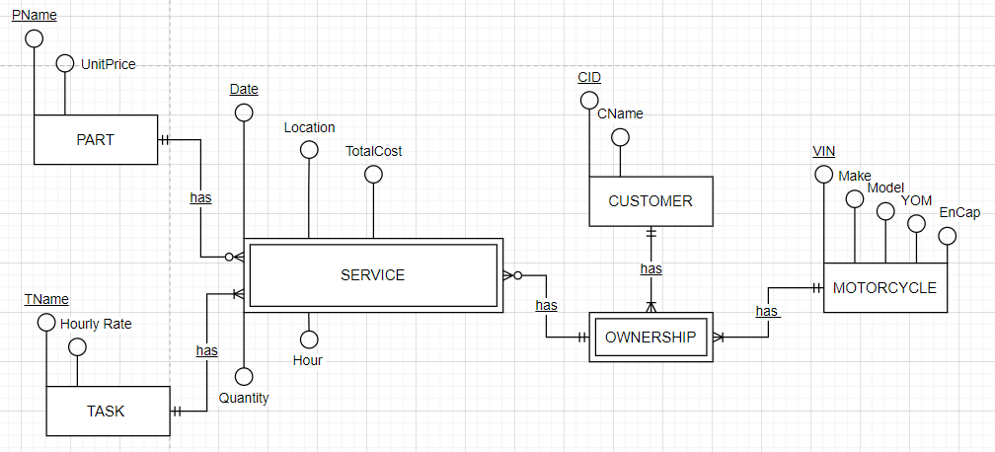

### Credit 5c

Paste your screen capture(s) for this task here.

MOTORCYCLE (VIN, Make, Model, YOM, EnCap)

PK (VIN)

CUSTOMER (CID, CName)

PK (CID)

OWNERSHIP (CID, VIN)

PK (CID, VIN)

FK (CID) REFERENCES CUSTOMER

FK (VIN) REFERENCES MOTORCYCLE

PART (PName, Unit Price)

PK (PName)

TASK (TName, Hourly Rate)

PK (TName)

SERVICE (CID, VIN, PName, TName, Date, Location, TotalCost, Quantity, Hour)

PK (CID, VIN, PName, TName, Date)

FK (CID, VIN) REFERENCES OWNERSHIP  
FK (PName) REFERENCES PART

FK (TName) REFERENCES TASK

### Credit 5d

Paste your screen capture(s) for this task here.

CREATE TABLE MOTORCYCLE (  
VIN NUMBER,

MAKE VARCHAR (100),

MODEL VARCHAR (100),

YOM DATE

EnCap INT  
PRIMARY KEY (VIN)  
);  
CREATE TABLE CUSTOMER (

CID INT,  
CNAME VARCHAR (100),  
PRIMARY KEY (CID)  
);  
CREATE TABLE OWNERSHIP (

VIN INT,

CID INT,  
FOREIGN KEY (VIN) REFERENCES MOTORCYCLE (VIN)  
FOREIGN KEY (CID) REFERENCES CUSTOMER (CID)  
);

CREATE TABLE PART (  
PNAME VARCHAR (100),

UNITCOST INT,  
PRIMARY KEY (PNAME)  
);

CREATE TABLE TASK (  
TNAME VARCHAR (100),  
HOURLY RATE INT

PRIMARY KEY (TNAME)  
);

CREATE TABLE SERVICE (

CID INT

VIN INT

PNAME VARCHAR (100)

TNAME VARCHAR (100)

DATE DATE

LOCATION VARCHAR (100)

TOTAL COST INT

QUANTITY INT

HOUR INT

PRIMARY KEY (CID)

PRIMARY KEY (VIN)

PRIMARY KEY (PNAME)

PRIMARY KEY (TNAME)

PRIMARY KEY (DATE)

FOREIGN KEY (CID) REFERENCES OWNERSHIP (CID)

FOREIGN KEY (VIN) REFERENCES OWNERSHIP (VIN)

FOREIGN KEY (PNAME) REFERENCES PART (PNAME)

FOREIGN KEY (TNAME) REFERENCES CUSTOMER (CID)

### Credit 5e

Paste your screen capture(s) for this task here.

|  |  |  |
| --- | --- | --- |
| CustID | Name | Phone |
| 125 | John Coles | 0401112233 |
| 278 | Erin Trump | 0466121455 |
| 721 | Emma Knox | 0423544117 |

|  |  |
| --- | --- |
| CarRego | MakeModel |
| 1AU8HK | Mazda 3 |
| 1KA2CA | Toyota |
| 1CZ8JK | Camry |
| 1LM3AB | Hyundai i30 |

|  |  |  |  |
| --- | --- | --- | --- |
| CustID | CarRego | StartDate | ReturnDate |
| 125 | 1AU8HK | 31/08/2020 | 7/09/2020 |
| 125 | 1LM3AB | 14/11/2020 | 21/11/2020 |
| 278 | 1AU8HK | 12/09/2020 | 19/09/2020 |
| 278 | 1KA2CA | 1/10/2020 | 8/10/2020 |
| 278 | 1CZ8JK | 10/11/2020 | 12/11/2020 |
| 278 | 1AU8HK | 26/11/2020 | 1/12/2020 |
| 721 | 1LM3AB | 10/09/2020 | 13/09/2020 |

### Credit 5f

Paste your screen capture(s) for this task here.

START TRANSACTION

INSERT INTO ACTION (ActionID, ActionDateTime, Action, ProdID, ProdQty, ProdCost)

VALUES (1008, 21/01/2001, Purchase, G43546, 2, 2100);

UPDATE PRODUCT

SET QtyInstock = QtyInstock + 2

INSERT INTO ACTION (ActionID, ActionDateTime, Action, ProdID, ProdQty, ProdCost)

VALUES (1026, 23/01/2021, Return, G43546, -1, 1050);

UPDATE PRODUCT

SET QtyInStock = QtyInstock +1;

END TRANSACTION

Explain when the sale or refund operation can go smoothly or go wrong.

- A sale can go easily when there are 0 products brought or discounted

- In addition, transaction will be smooth if the quantity of bought products is a smaller amount than the quantity of products available

- A sale can have errors if the product amount available is 0 or the quantity bought is greater the quantity available.

- A refund fails if product refund amount is 0.

- Both actions will fail if during the exchange, it occurs an electrical blackout

### - Transaction committed refers to the successful transaction that make all the changes permanent

### - Transaction roll back refers to the unsuccessful transaction that make all the changes cancelled